**Lab Report: 02**

**Title: Use Case Specifications and Diagram**

***Course title: Software Engineering Information System Design Laboratory***

*C* *ourse code: CSE-404*

*4th Year 1st Semester Examination 2024*

Date of submission

15-08-2025



**Submitted to-**

***Md. Humayun Kabir***

***& Dr. Md Musfique Anwar***

*Professor Department of Computer Science and Engineering Jahangirnagar University Savar, Dhaka-1342*

|  |  |  |  |
| --- | --- | --- | --- |
| **SI** | **Class Roll** | **Exam Roll** | **Name** |
| **01** | **391** | **210911** | **Md Khaled Mahmud Jon** |

**1. Introduction**

The ThesisHub system automates the thesis supervision process in the CSE department. Currently, student group formation, teacher preference submission, and supervisor allocation are handled manually, leading to inefficiency, delays, and human errors. ThesisHub aims to provide a transparent, efficient, and automated workflow for students, teachers, and the chairman.

**2. Objectives**

* Automate student group formation and teacher preference submission.
* Automatically assign supervisors based on CGPA and availability.
* Enable teachers to assign tasks and evaluate students systematically.
* Provide notifications, dashboards, and reports for all users.
* Ensure fairness, transparency, and data integrity throughout the thesis workflow.

**3. Procedure / Methodology**

1. **User Authentication:** Students, teachers, and chairman log in with role-based access.
2. **Group Formation:** Students form groups of two members.
3. **CGPA Processing:** System calculates group CGPA for ranking.
4. **Preference Submission:** Students submit preferred teachers for supervision.
5. **Supervisor Allocation:** Chairman/system automatically assigns supervisors based on rules.
6. **Task Assignment & Submission:** Teachers assign thesis tasks; students submit deliverables.
7. **Evaluation & Marking:** Teachers evaluate tasks and provide marks.
8. **Notifications & Reporting:** System sends updates and generates reports.

**4. Use Case List**

**🟦 Use Case 1: User Registration & Login**

* **Actors:** Student, Teacher, Chairman
* **Precondition:** User is not logged in
* **Postcondition:** User is authenticated and redirected to their dashboard
* **Description:** Handles registration, login, and role-based access
* **User Scenario:**
  + A student signs up using their ID and password
  + A teacher registers and awaits admin approval
  + Chairman logs in with admin credentials

**🟦 Use Case 2: Group Formation**

* **Actors:** Student
* **Precondition:** Student is logged in and not already in a group
* **Postcondition:** Group is created and saved in the system
* **Description:** A student creates a group and sends invite to another student
* **User Scenario:**
  + Student A sends a group request to Student B
  + Student B accepts, and the group is finalized

**🟦 Use Case 3: CGPA Submission & Group Ranking**

* **Actors:** Student, Chairman
* **Precondition:** Group is created
* **Postcondition:** Group CGPA is calculated and stored
* **Description:** Group CGPA (higher CGPA among two) is used for sorting
* **User Scenario:**
  + Group CGPA is auto-calculated from student profile
  + Chairman views the sorted list

**🟦 Use Case 4: Submit Teacher Preferences**

* **Actors:** Student
* **Precondition:** Group is created and logged in
* **Postcondition:** Preference list is saved
* **Description:** Groups choose up to 3 teachers in ranked order
* **User Scenario:**
  + Group submits a preference list of teachers for thesis supervision

**🟦 Use Case 5: Supervisor Allocation**

* **Actors:** Chairman
* **Precondition:** Groups and preferences exist
* **Postcondition:** Supervisors are assigned respecting quota
* **Description:** Automatically or manually assigns teachers to groups
* **User Scenario:**
  + Group 1 (top CGPA) is matched to Teacher A (available)
  + Group 2 is assigned to next preferred teacher

**🟦 Use Case 6: Task Assignment**

* **Actors:** Teacher
* **Precondition:** Group is assigned to the teacher
* **Postcondition:** Task is visible to the group
* **Description:** Teachers create thesis tasks with instructions and deadlines
* **User Scenario:**
  + Teacher assigns “Literature Review” task with deadline

**🟦 Use Case 7: Task Submission**

* **Actors:** Student
* **Precondition:** Task is assigned
* **Postcondition:** Task is submitted and stored
* **Description:** Students submit deliverables for evaluation
* **User Scenario:**
  + Group uploads report before deadline

**🟦 Use Case 8: Task Evaluation**

* **Actors:** Teacher
* **Precondition:** Group has submitted a task
* **Postcondition:** Marks and feedback saved
* **Description:** Teacher evaluates work and assigns scores
* **User Scenario:**
  + Teacher gives 80/100 for submitted task

**🟦 Use Case 9: Final Thesis Marking**

* **Actors:** Teacher
* **Precondition:** Final evaluation ready
* **Postcondition:** Final mark saved
* **Description:** Teacher submits group’s final mark out of 100
* **User Scenario:**
  + Teacher finalizes mark: Group gets 85/100

**🟦 Use Case 10: Notification System**

* **Actors:** All
* **Precondition:** Trigger event (task assigned, group assigned, etc.)
* **Postcondition:** Notification sent to relevant users
* **Description:** Notify users about status updates
* **User Scenario:**
  + Student is notified when teacher assigns new task

**🟦 Use Case 11: Admin Dashboard & Manual Override**

* **Actors:** Chairman
* **Precondition:** System in operational state
* **Postcondition:** Admin can override assignments
* **Description:** Chairman can reassign supervisors, manage users
* **User Scenario:**
  + Chairman reassigns Group X to Teacher Y in special case

**🗂 Summary Table of Use Cases**

|  |  |  |  |
| --- | --- | --- | --- |
| Use Case Name | Actors | Preconditions | Postconditions |
| User Registration & Login | Student, Teacher, Chairman | Not logged in | Redirected to dashboard |
| Group Formation | Student | Logged in, not in group | Group created |
| CGPA Submission & Ranking | Student, Chairman | Group created | Group sorted by CGPA |
| Submit Teacher Preferences | Student | Group formed | Preference list saved |
| Supervisor Allocation | Chairman | Preferences submitted | Supervisor assigned |
| Task Assignment | Teacher | Group assigned | Task visible to group |
| Task Submission | Student | Task exists | Submission saved |
| Task Evaluation | Teacher | Task submitted | Feedback & marks saved |
| Final Thesis Marking | Teacher | Tasks evaluated | Final mark saved |
| Notification System | All | Trigger event | Notification sent |
| Admin Override | Chairman | Allocation done | Data manually modified |

**5. Use Case Diagram**

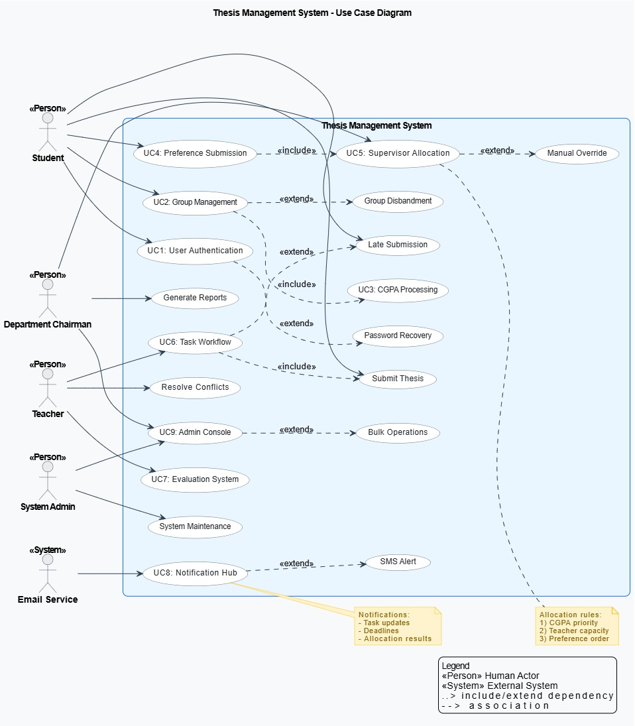

**7.Discussion**

* The system improves efficiency by automating group formation and allocation.
* Reduces human errors and increases transparency in supervision assignment.
* Real-time notifications ensure students and teachers stay updated.
* Future improvements: support multiple departments, mobile app interface, advanced analytics.